Jira Fundamentals

1. Understanding Jira Projects and Project Types
A Jira Project is a workspace that contains all related issues, workflows, boards, and configurations for a specific goal or product.
1.1 Types of Jira Projects
Jira provides two major project types:
Feature | Team-Managed Project | Company-Managed Project
Control | Managed by team members | Managed by Jira admins
Customization | Limited | Advanced & flexible
Workflow editing | Simple | Complex workflows
Best suited for | Small teams, learning | Large organizations
When to Use
- Team-Managed → College projects, quick setups
- Company-Managed → Enterprise projects, internships

Hands-On Lab: Create a Project
- Go to Projects → Create Project
- Choose Scrum or Kanban
- Select Team-Managed Project
- Name project: My First
- Click Create
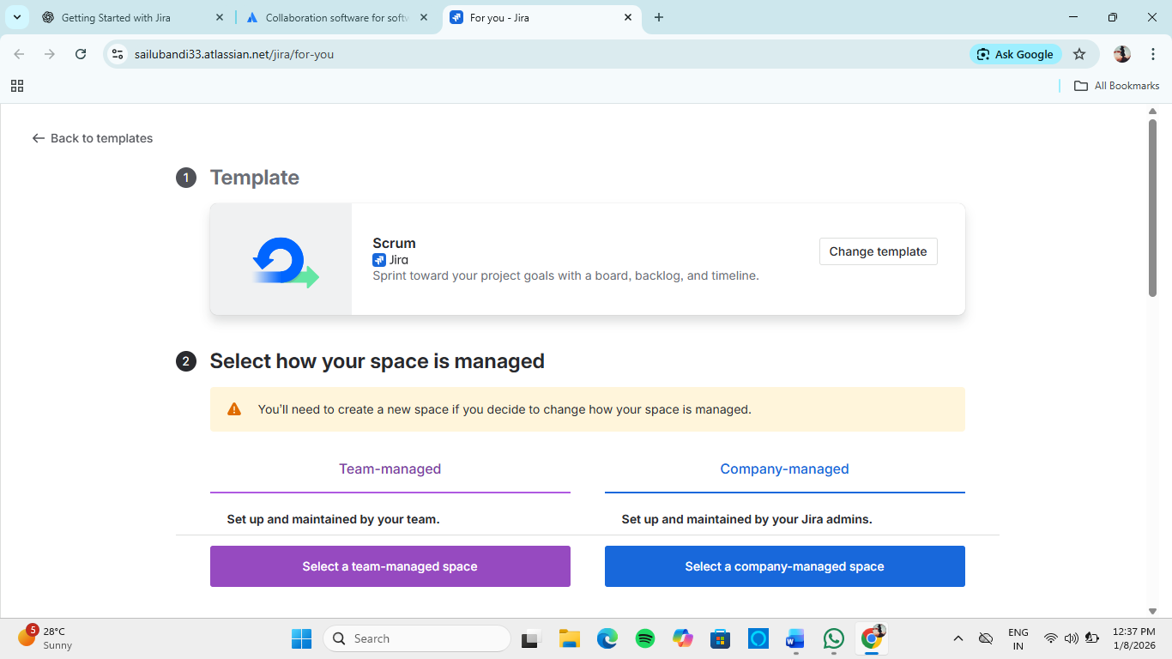
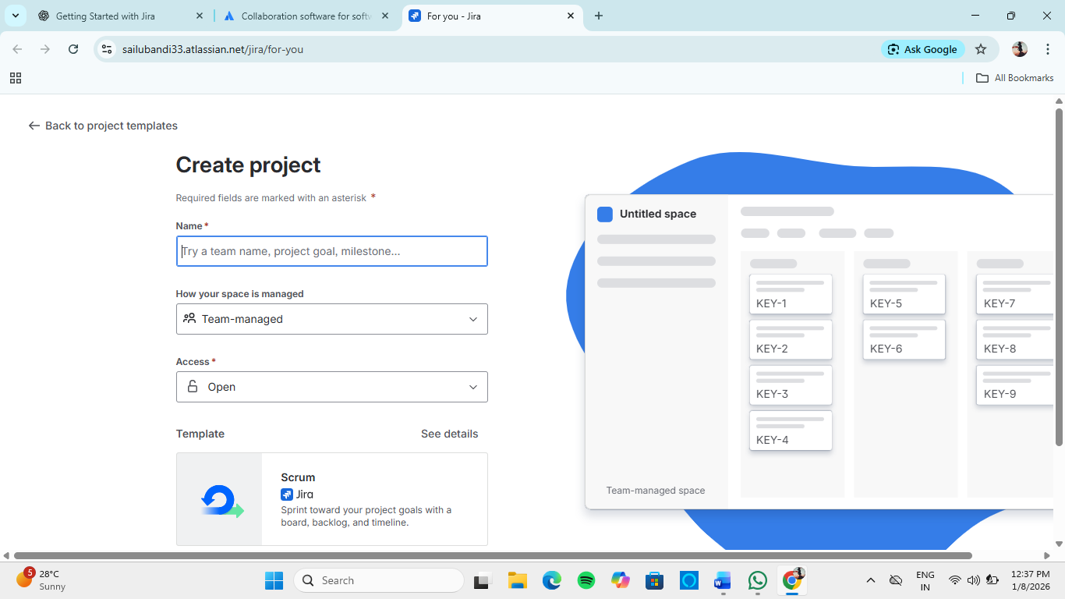

2. Jira Issue Types Explained
An Issue represents a single piece of work.
2.1 Core Issue Types
Issue Type | Purpose
Epic | Large feature containing multiple stories
Story | User requirement
Task | General technical or non-user work
Bug | Defect or error
Subtask | Smaller work under a parent issue

Example
- Epic: Online Exam System
  - Story: Student login
    - Subtask: UI design
    - Subtask: Backend validation

3. Creating and Managing Issues in Jira
Hands-On Lab: Create an Issue
- Click Create
- Select:
  - Issue Type: Story
  - Summary: order page
  - Description: Create A Frontend With All Functionalities
- Assign issue
- Click Create
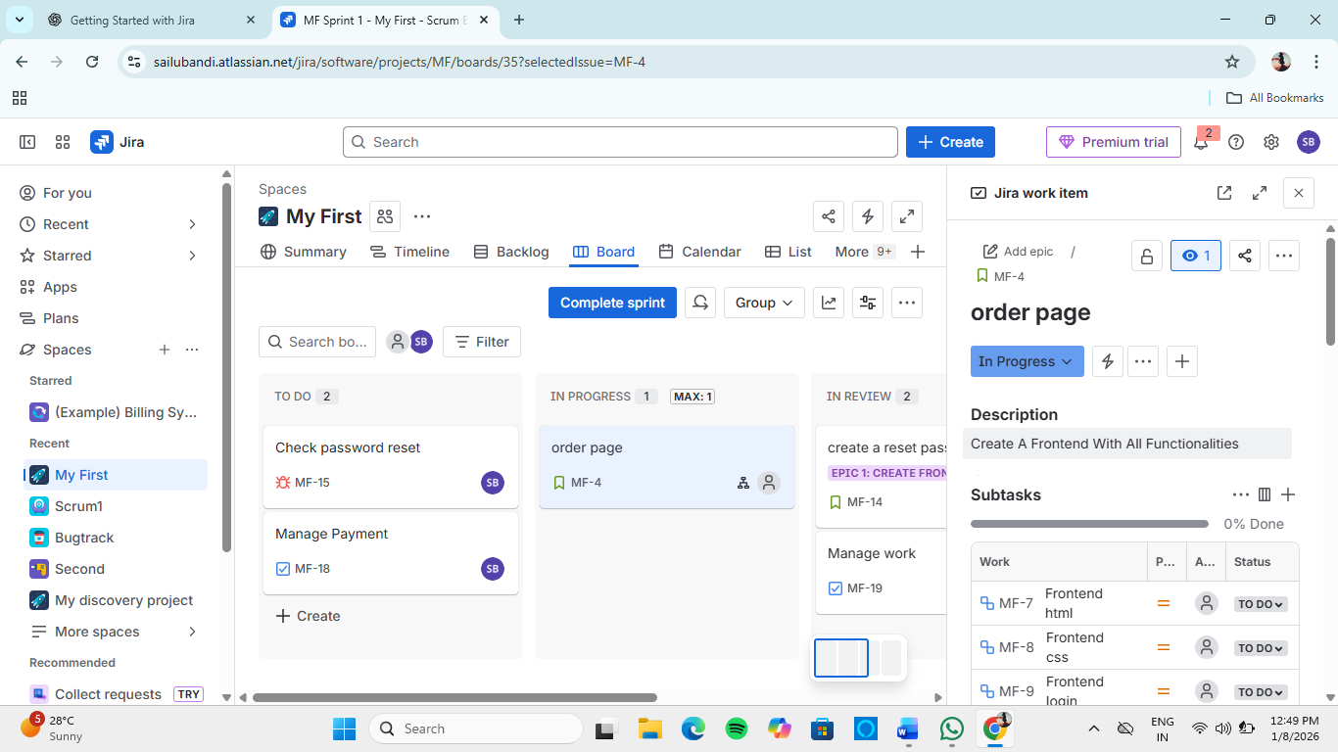
Managing Issues
- Edit summary or description
- Change priority
- Assign or reassign
- Transition issue through workflow

4. Issue Hierarchy and Linking Issues
4.1 Issue Hierarchy
Jira follows a clear hierarchy:
Epic
└── Story / Task
└── Subtask
- Epic groups related work
- Stories/Tasks represent actual work
- Subtasks break work into smaller steps

4.2 Linking Issues
Issues can be linked using relationships:
- Blocks / Is blocked by
- Relates to
- Duplicates
Hands-On: Link Issues
- Open an issue
- Click Link issue
- Choose link type
- Select issue key
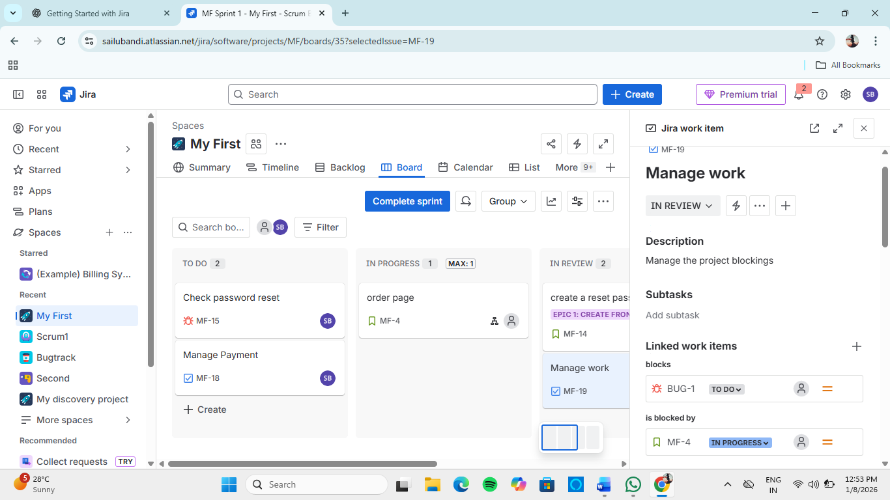

5. Working with Kanban and Scrum Boards
5.1 Scrum Board
- Sprint-based work
- Used for Agile development
- Has backlog and sprint planning
Key Features:
- Sprint planning
- Burndown chart
- Velocity tracking

5.2 Kanban Board
- Continuous workflow
- No sprints
- Focus on work-in-progress (WIP)
Key Features:
- Visual flow
- WIP limits
- Cycle time tracking

Hands-On: Board Usage
- Open Board
- Drag issue between columns
- Observe status updates
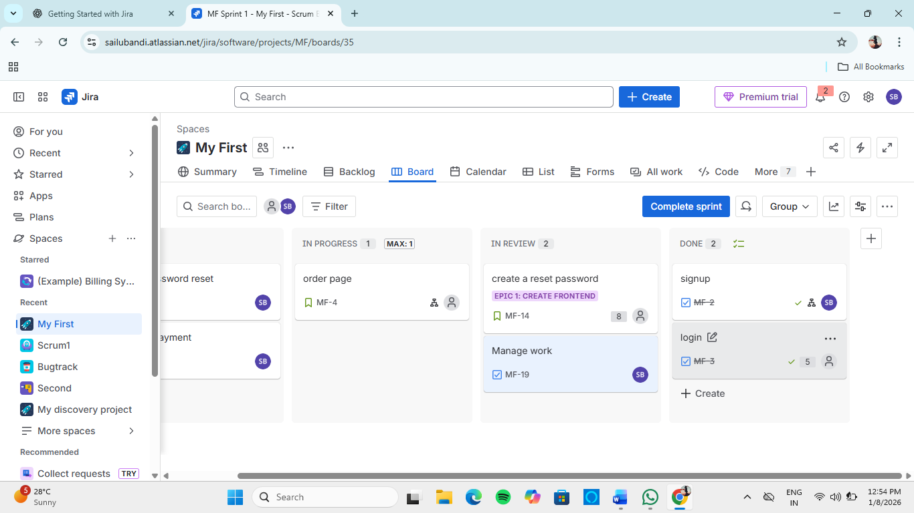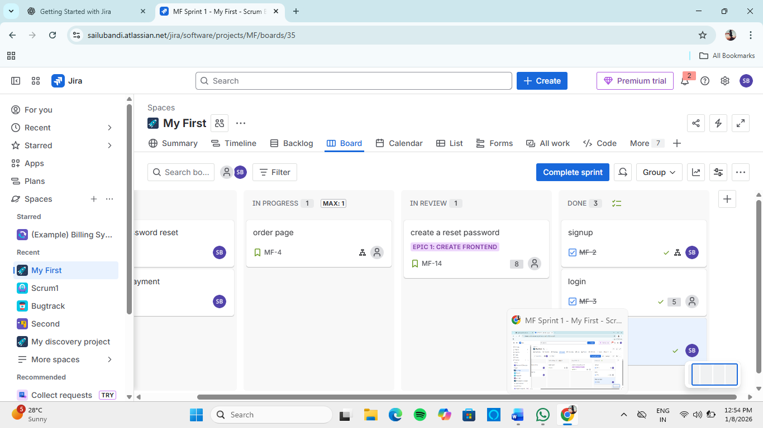

6. Backlog, Board, and Detail Views
6.1 Backlog View
- Shows all pending work
- Used for planning and prioritization
- Mainly used in Scrum projects

6.2 Board View
- Visual tracking of work
- Shows issue movement
- Used daily by teams

6.3 Detail (Issue) View
- Shows full issue information:
  - Description
  - Status
  - Assignee
  - Comments
  - History

Hands-On: Explore Views
- Open Backlog
- Select an issue
- View Board
- Click issue to open Detail View

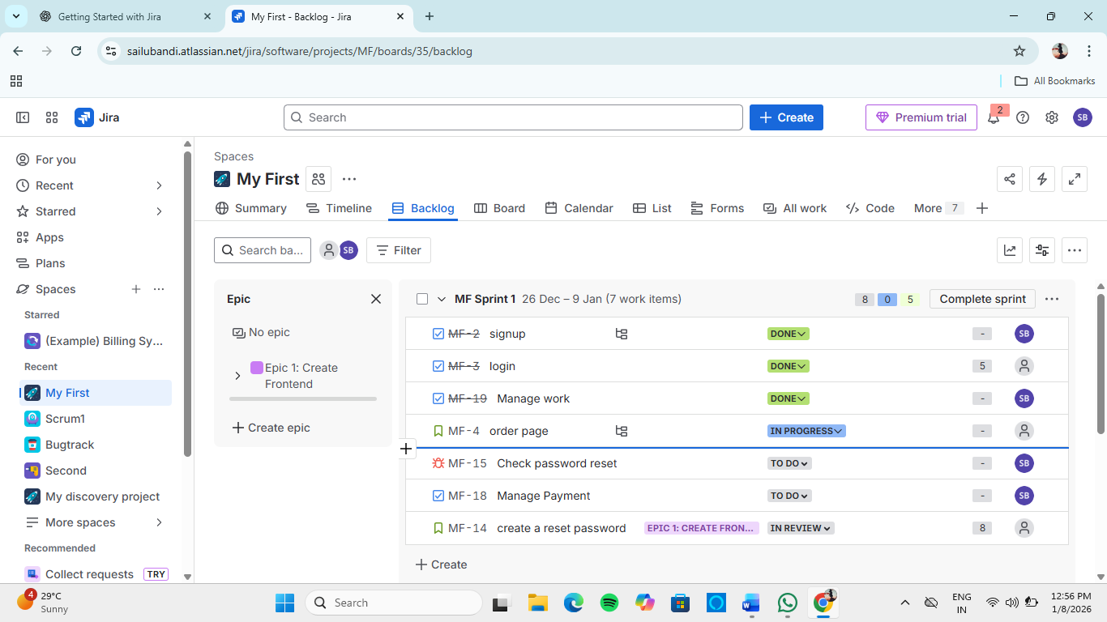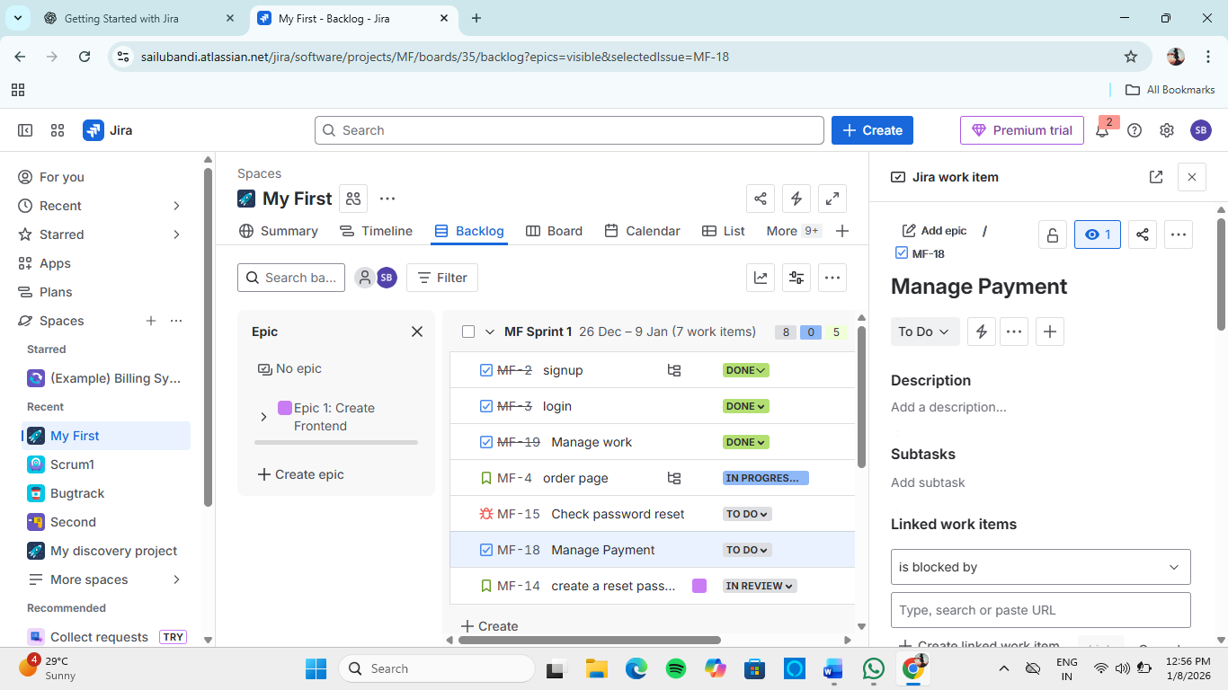

7. Key Learning Outcomes
After completing Jira Fundamentals, learners can:
- Understand project types and choose correctly
- Create and manage Jira issues
- Use issue hierarchy effectively
- Work confidently with Scrum and Kanban boards
- Navigate backlog, board, and issue views
